**Temperature Measurement Using MATLAB Simulink**

**AIM:**

To measure and control the temperature of Heat Exchanger using MATLAB Simulink

**TOOLS REQUIRED:**

MATLAB Software

**PROCEDURE:**

1. Open MATLAB Simulink

2. Place controller, transfer function, delay as per the process requirements

3. Connect the components as shown below

4. Run the Simulink

5. Infer the response

**CIRCUIT DIAGRAM:**

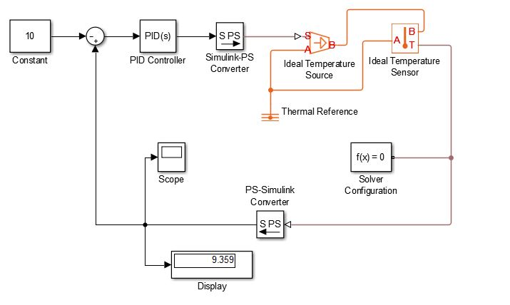

**OUTPUT GRAPH:**

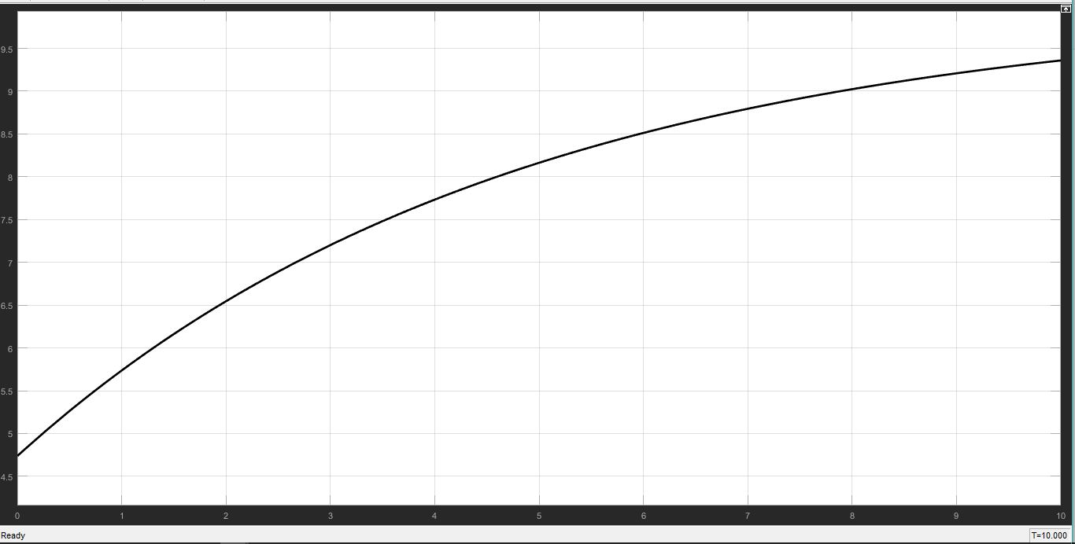

**RESULT:**

Thus the temperature has been measured and controlled using MATLAB software.